ACGL Keeper League Rule Guide
Steve Eisler
Oct-2023

v2.0

Contents
Overview 3
ACGL Credo 3
Fair Play 3
ACGL Evolution 3
Tracking 3
Winnings 3
Fees 4
Roster Make-Up 4
Active Roster (20 mandatory) 4
Bench Slots (3 available) 4
IR Slots (2 available) 4
Prospects 5
Roster Rules 5
Salary Cap 5
Active Roster Scoring 5
Commissioner Administered Moves 6
Self-Administered Moves 6
Using IR 6
Qualifying Players 6
Putting a player on IR 7
IR Replacement Players 7
Return From IR 7
Using Bench 7
Dressing a bench Player / Benching a player 7
Filling your empty Bench slots 8
Performing Drops 8
Performing Pickups - FA/Waivers 9
Qualifying Players 9
Pickup Cost 9
Limited number of pickups (7 per season) 9
NEW Cannot Trade Claimed Players within 2 periods of picking them up 9
Submitting a Free Agent pickup via Waiver Claim 9
Waiver Order 10
NEW - Fantrax Waiver Instructions 10
STEP 1 - Click on the plus on the FA player you want to add and submit via the sub menu 10
STEP 2 - Organize your players on the roster Tab/screen under Pending Transactions 11
STEP 3 - Wait and see Wednesday mornings! 12
Using Prospects 12
Qualifying Players 12
Call-up/Demote a Prospect 12
Graduating a Prospect 12
Making Trades 13
Trade Deadline 13
Assets available for Trade 13
Submitting a trade 13
Voting against the trade 13
Trades that put you over or under on Rules 14
Trading Picks 14
Trading Prospects originally pulled from Free Agency (Rare) 14
Cap Retention 14
Offseason Activities 15
Rule Changes 15
Draft Lotteries 15
Recorded History 15
Trades Reopen 15
Roster Player Drops 15
Draft Day 16
Pre-Draft 16
Prospect Draft (5 rounds) 16
Free Agent Draft (7 rounds) 16
Post Draft Roster Cleanup 17
Season Start 17
Other Rules Items 17
Players without NHL Contracts - Holdouts 17
Players with multiple positions 17
Foreign-fled Player Protection 17
League Expansion Rules - TO CLEAN NEXT GO AROUND 18
Team Departure and Retraction Draft 18

Overview

ACGL Credo
ACGL is a Fantrax operated Dynasty League which uses some somewhat unique rules. We strive to be as NHL-like as possible, including things like adopting the NHL cap. the NHL active roster size (plus one extra bench slot), prospect pools, drafting (based on team performance), trades, and a limited Injured Reserve. Like NHL teams, we strive for the key to victory to be less focused on in-season free agent moves (like most pools) as we are about drafting (both offseason roster creation and prospects) and trades.
We also force all GMs to drop 4 players at the end of the year to allow for poorly performing teams to have a better shot the following year.

Fair Play
Since the site will be 100% administered by the website, all rules will be enforced within. There will be no complaining about missed rules or changes to settings mid-season. What is there is there.

ACGL Evolution
This pool has been constantly evolving as we try to make the pool
- more exciting,
- more balanced for hardcores and casuals alike,
- more NHL-like,
- have more GM interactions (trades), and
- easier for the daily operations for the commissioners

Tracking
All relevant activities, and useful information outside of this instruction document can be seen in the following shared spreadsheet https://docs.google.com/spreadsheets/d/1sR2YZccONrv8xC3mwynEKZTyAcRalZbi/edit#gid=2066659349
NOTE: The multiple tabs.
There will no longer be move tracking here - it will all be done on site. Amounts for pickups will be calculated at the end of season.

Winnings
Winnings are calculated based on a percentage of the total money entered into the league. This is based on the fees upon entry as well as any fees accrued over the course of the year.
Winnings are broken down as follows
1st Place (Most Points) | 65% of all Fees
2nd Place | 25% of all fees
3rd Place | 10% of all fees
4th Place | Free entry into next year
NOTE: A Fantrax Fee of $131 (TBD) is removed from the pot before these amounts are calculated

Fees
NEW The following details the fees applied over the course of the year.
Entry Fee | $45
Player Pickup Fee (Max 7 per team per season) | $5
Player Drop Fee | $0
NEW 3rd Last Place Penalty | $15 carried into next year’s prizes, applied at end of year
NEW 2nd Last Place Penalty | $30 carried into next year’s prizes, applied at end of year
Last Place Penalty | $45 carried into next year’s prizes, applied at end of year
NOTE: There are no longer any fees for dropping players, but note that you MUST dress a full roster every period.
IMPORTANT: If teams decide to drop players for the purposes of tanking, this will be halted, reversed and potentially penalized. Dressing injured players, however, will NOT be reprimanded as such.

Roster Make-Up

Active Roster (20 mandatory)
At all times a GM must have an active roster of 20 Players
- 12 FWD
- 6D
- 2G
These players count against your cap and are the only players that can accrue points for your team over the period in question

Bench Slots (3 available)
The bench has 3 optional slots and can consist of any player type.
These players also count against the cap but do NOT count accrue points every period. They are there as potential substitutes for injured or poorly performing players. Or they can house players that you do not wish to drop but possibly carry into future seasons.

IR Slots (2 available)
The IR Slots can also consist of any player type, however a player can only be moved into an IR slot if, they were originally on your roster, and Fantrax records them as one of the following states
- On NHLs Injured Reserve
- Day to Day
- Out (Personal Reasons)
- Inactive
- Suspended

These players DO NOT count against your players salary cap.

Prospects
A GM has 26 Prospects slots they can use to store prospects in. These slots accrue no points. On top of this, a GM can put any number of prospects on their active roster, allowing for (technically) more than 26 total prospects on a team.
A prospect is defined by the following criteria
- Is a FWD or D that has yet to play their 41st game
- Is a G that has yet to play their 26th game
Prospects do not count against the salary cap, and can be substituted into and out of your active roster and bench as needed.
NOTE: A player may go over on games DURING a period. If so, they must be moved out of a prospect spot before the next period starts or they will be automatically dropped to waivers (more on waivers below).

Roster Rules

Salary Cap
The league salary cap is dictated by the NHL equivalent every year.
Your teams total salary combines all of the below
- The salaries of all players on your roster and your bench
- Any buyout penalties accrued from using a non-annual buyout (see BUYOUTs section below)
  - NOTE: Midseason buyouts are no longer applicable. Only penalties from previous seasons will apply.
- Any retained cap as part of a previous player trade

For the 2023-2024 season this amount is 82.5 million

Active Roster Scoring
Only players on your active roster will accrue points.
A scoring period lasts 2 weeks. As such, whatever roster you have dressed on the day of the period start (before game start time) is the roster you will have for that 2 week period.
Trades, pickups, drops, demotion or promotion will not take effect until the following period.
Scoring is as follows
Stat | Forward Points | Defense Points | Goalie Points
Goals | 1.0 | 1.5 | 5.0
Assists | 1.0 | 1.0 | 1.0
Penalty Minutes | 0.25 per min | 0.25 per min | 0.25 per min
Power Play Goals |  | 0.50
Short Handed Goals | 1.0 | 1.0
Even Strength Goals |  | 0.50
Game Winning Goals | 1.0 | 1.0
Shootout GWG | 1.0 | 1.0
Hat trick | 2.0 | 2.0
Shots |  | 0.02
Hit | 0.05 | NEW 0.075
Blocked Shot | 0.04 | 0.10
Win |  |  | NEW 2.1
Shut Out |  |  | 3.0
Over-Time Loss |  |  | 1.0
Save |  |  | NEW 0.02

Commissioner Administered Moves
The only move that counts as requiring administrator help is Trades that Retain Salary. This will be applied as a player hit and recorded in the spreadsheet for future seasons tracking.

Self-Administered Moves
The following moves can be performed by the GMs themselves, typically on period turnover dates but can be done in advance (you can already set next period’s rosters).
- Moving a player into an IR slot, and replacing him with a Bench Player or Prospect
- Trading picks, prospects and players to other GMs
- Voting on other GM trades
  - NOTE: this is anonymous (
- Dropping a player to make room for a prospect
  - NOTE: All drops are free of cost
- Demoting prospects back to the minors
- Picking up a Free Agent (or multiple) via end of period Waivers to fill a roster spot or bench spot (Cost $5)
  - May happen due to IR, free bench spot or a player drop.

Using IR

Qualifying Players
A player can be put on IR if Fantrax has them in one of the following states
- On NHLs Injured Reserve
- Day to Day
- Out (Personal Reasons)
- Inactive
- Suspended
The player must be removed from IR the following period if they are no longer in one of those states.

Putting a player on IR
When a GM decides they want one of Their players to move to the IR they may do one of the following
- Put a prospect in that active players space
- Put a bench player in that active players space
- Pickup a Free Agent at period turnover via end of period waivers
IMPORTANT: If you use prospects or bench players as replacements, then when the IR player returns, there MUST be room (roster max + cap) for them to come back. If not, then you will be forced to drop a player on your roster, or the injured player themselves.

IR Replacement Players
There is no longer a concept of IR Replacements. Once you pick up a player they are yours. You can choose to drop any other player when this IR player returns so long as you are still cap and roster compliant.
Acquiring an IR replacement is the same as picking up a free agent - it is based entirely on waiver order.
This also costs one of your 7 uses. IMPORTANT: If you're going to use this for IR, you had better be sure the player is worth keeping and out for some period of time.

Return From IR
If a player is no longer with an IR status, then they are forced to be moved off of IR. Alternatively, a GM may optionally bring a player with an IR status off of IR (if they feel they will be back early in a period, or want to put another more expensive player on IR) early if they so decide.
When a player returns from IR, then space must be made for that players return, by doing one of the following
- Dropping another roster player to waivers
- Swapping an injured player in while subbing the returning player in.
  - NOTE: This could cause cap and roster size violations.
- Drop the IR returning player to waivers
- Trade a player away (including the IR player) to make space
  - NEW A traded player can now go straight to your IR as this move can happen before period start date.
NOTE: In all cases you must be cap and roster compliant

Using Bench

Dressing a bench Player / Benching a player
All GMs can move bench players into and out of the bench themselves before each period start.
NOTE: You still need to dress a complete 20 player active roster at all times.

Filling your empty Bench slots
You can, at any point
- Put a prospect onto your bench
  - NOTE: When a prospect graduates they will need to go somewhere… bench may be the place.
- Pickup a Free Agent (Cost $5)
  - This can now happen after the trade deadline.
  - This move is submitted to the commissioner via the Fantrax Message Forum
  - Any acquired player from free agency must remain on your team for 2 months.
- Trade for players
Processing these moves will not happen until the next period begins.

Performing Drops
Each Team has an Unlimited number of drops, which can be used for
- Making space for a waiver/FA pickup
- Making space for a trade
- Making Space for a Prospect Graduating to FA
- Picking up another prospect from FA and putting them in the prospects slot
- Making Space for a Bench player
Ultimately it will be used to make space for another player either via cap or by roster spot.
After a Drop your team must be cap and roster compliant before the next period start.

Performing Pickups - FA/Waivers

Qualifying Players
Any player not part of anyone's roster is eligible to be picked up. This now includes prospects. They can be picked up and put into an empty prospect slot.
Every time a player or prospect is dropped by a GM, they automatically go to Waivers and made available for the next period UNLESS they are dropped within 24 hrs of the period cutover - in this case they will carry over to the next period.
Once a period starts, ALL Free agent players will be put on waivers and made available for pickup the following period.
NEW - Any players received in the pickup can go directly onto your IR (the team doesn’t have to be cap compliant when received)

Pickup Cost
Picking up a player from waivers/free agency will cost the GM $5 per player.

Limited number of pickups (7 per season)
Being a keeper league we are encouraging working with your active roster.
Over the course of the entire year, a Team can only pickup 7 free agents. This includes
- IR replacements
  - NOTE: These can be kept even after the original player comes off IR (by dropping another player).
- Filling Bench Spots
- Picking up Prospects that are currently playing in the NHL
- Filling space on your roster with recent drops.
NOTE: The number of pickups is based on a league average of both IR replacements and FA pickups

NEW Cannot Trade Claimed Players within 2 periods of picking them up
This is to prevent pickup and trade scenarios to players that are out of moves. A pickup should be done so the player enhances THE team that claimed them.
The date is when the player makes the team not when the claim is made (which can happen mid period).
NOTE: You can still drop the player if you like.

Submitting a Free Agent pickup via Waiver Claim
This will now be entirely administered via the site.
At the beginning of each period, including before season start, ALL players go on waivers. As such, you will need to submit a claim (or multiple) to acquire the player you want. This means multiple GMs can bid on the same player(s).
Who ends up getting the player will be based on the current waiver order (see below).
Waivers will process the same day as the period cutover date so all your claims/drops/etc. can be processed before game start time.

Waiver Order
Default waiver order is the same as the league's draft order. When a player makes a waiver selection then they are put to the bottom of the priority list.
EXAMPLE: If you submit two pickup requests, you will need to prioritize those pickups. If you claim the first one you will be put to the bottom of the priority list. If no one else claims the second one (since they would have higher priority) you will also receive the second.

NEW - Fantrax Waiver Instructions

STEP 1 - Click on the plus on the FA player you want to add and submit via the sub menu
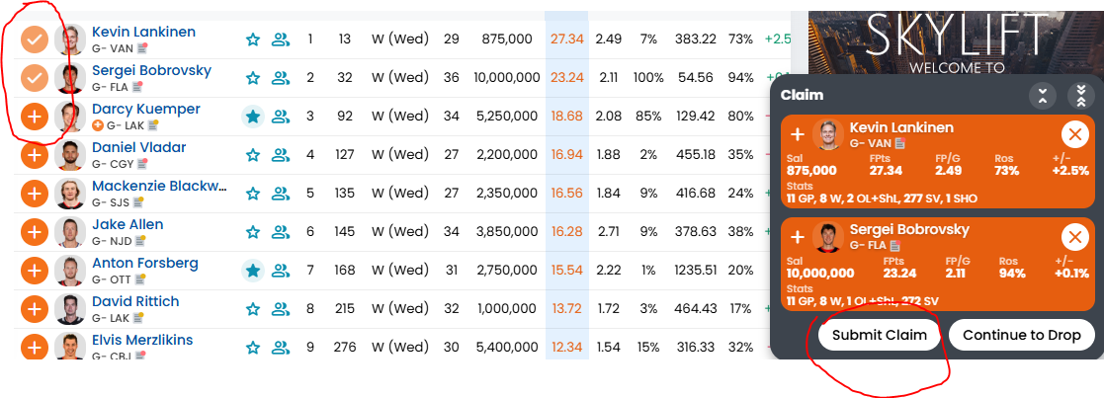You can add as many players you want using this method, including picking one goalie from a list of goalies.
NOTE: You don’t have to submit all players in a single move, as per the example above. You can submit them as separate moves and clean it up after.
NOTE: If you cannot add a player it is likely because you either have used all 7 of your season long moves, or the commissioner (Steve) hasn't put all players back on waivers yet (Just let him know he forgot).

STEP 2 - Organize your players on the roster Tab/screen under Pending Transactions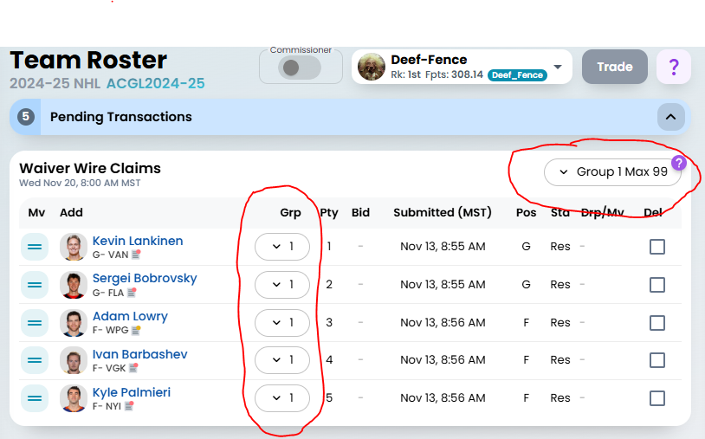
You’ll see the default above has everyone in the same “group” with a max of 99. This means that you will grab 99 players from this single group. Not a good default!!!! Change it!
Using this scenario, if I want to get 1 goalie and 2 forwards, I would create two groups using the group dropdown button. In my goalie group I would order my priority (top to bottom) and select max 1, and in my forward group I would order and select max 2. 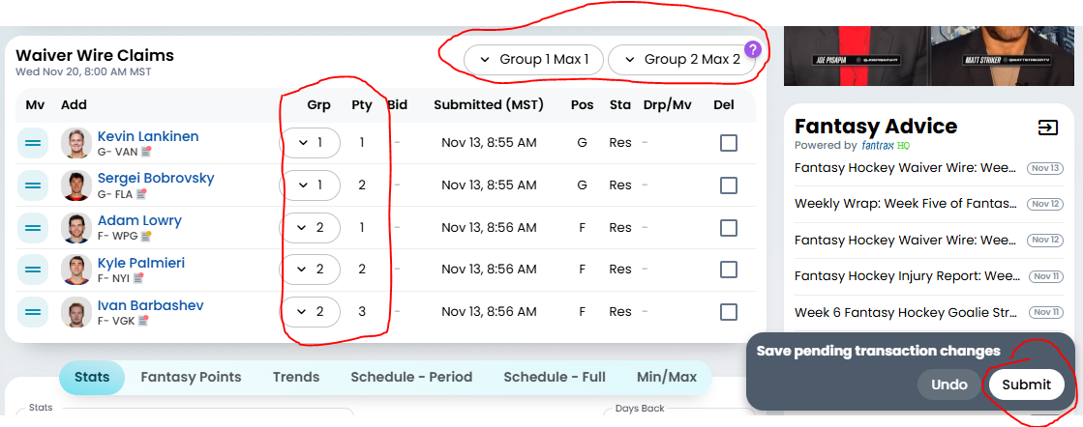
IMPORTANT - DON'T FORGET TO HIT THE SUBMIT BUTTON WHEN MANIPULATING YOUR WAIVER GROUPS AND MAXES. Reordering and grouping is NOT automatic - you have to hit the submit button.
IMPORTANT - Whenever you manipulate your waiver groups, priority or players, please double check the group and Max settings for that group. Apparently these reset in fantrax whenever certain changes are made.
NOTE - You can delete one or more rows by clicking the DEL checkbox and hitting the same submit button

STEP 3 - Wait and see Wednesday mornings!
- If no one else took the players you wanted you would end up with 3 players by the end of waiver processing based on the priority you wanted.
  - In this case Lankinen, Lowry and Palmieri
- If your top priority player was selected by another person., then your next prioritized player would be chosen.
  - If Lankinen and Lowry were taken, then you’d end up with Bobrovsy, Palmieri, and Barbashev
- If all the players in your group you wanted were selected by other teams, then you wouldn’t pick up any players from that group.
IMPORTANT - Don’t forget to dress the players you picked up and drop any excess roster or cap to be compliant before period start
IMPORTANT - And don’t forget that waivers run twice in one period. You won’t be able to dress players you acquired at the halfway mark until the following period cutover.
IMPORTANT - As per Fantrax: All groups are treated equally and in parallel, and are processed in random order. The system will not prioritize groups against each other. That is, the system may or may not process Group 1 before Group 2, but will prioritize claims within each group. Because groups are processed in parallel, you should never have the same players in multiple groups, as claims/drops executed in one group will cause claims/drops in other groups to be canceled.

Using Prospects

Qualifying Players
Any Forward or Defenseman that has yet to play 41 games, or any Goalie that has yet to play 26 games played that is drafted by the GM is considered a prospect. NOTE: A player may go over on games DURING a 2 week period. If so, they must be dealt with before the next period starts.
GMs have up to 26 prospects in their prospect slots at one time.
They can also have an additional number of prospects playing on their active roster, thus allowing for more than 26.
Any Free agent player that qualifies as a prospect can be picked up and used AS a prospect, provided they are playing in the NHL. If they are in the minors they will be excluded from the free agency list.
You can drop prospects at any point during the season if you wish to pick up another “playing” prospect.

Call-up/Demote a Prospect
At any point a prospect can be called up to an open roster spot. This is self administered by the GM at each period turnover.
Similarly, a GM may push his prospect back down to the pool at period turnover if they still qualify as a prospect.

Graduating a Prospect
If a prospect reaches their games over the course of a 2-week period, the GM must
- Drop the prospect to waivers
- Move the prospect to a bench spot
- Drop an active or bench player to make room for the prospect.
  - IMPORTANT: This is a free move from both a cost and a penalty perspective.
  - This can happen even if there is room on the bench and under the cap.
- Move the prospect to IR (if they are injured - an rare scenario)
NEW: Any prospect that graduates AFTER trade deadline day must now be dealt with in the same way as the regular season. Dress him or drop him.

Making Trades

Trade Deadline
Our pool uses the same trade deadline as the NHL, however our cutover date is midnight that day (end of day). Any trades submitted after that date will be rejected. Any before will be voted on and processed as indicated below.
If you still have FA pickups remaining, you can still drop and add after the trade deadline.

Assets available for Trade
Trades can include players (including cap retention), prospects, prospect picks (up to 3 years in future), and regular draft picks.
NOTE: There are only 5 prospect picks available and 7 regular season picks. This is distinguished between rounds 1-5 (Prospect) and rounds 6-12 (Regular) where round 6 actually represents round 1 of the regular draft.
IMPORTANT:
- No GM can have more than 3 retained salary transactions on the books at one time.
- Unlike the NHL, you cannot retain salary on a player contract that has already retained salary against it.

Submitting a trade
All trades will be submitted through the Fantrax website (NOT the Message Forum). The receiving GM can elect to reject, alter or accept the trade.
NEW - Any players received in the trade can go directly onto your IR (the team doesn't have to be cap compliant when received)
You cannot submit a trade after the trade deadline

Voting against the trade
If the corresponding GM accepts the trade, then commissioners have a 2 day window (TBD) to anonymously veto the deal (if they think it unfair) before it gets processed.
IMPORTANT: This means if you want the deal processed before the next period it must be submitted and agreed to 2 days before the next period cutoff.
NEW If we receive 5 votes to Veto (almost half the league minus the two trading teams) then the trade will be negated.
NOTE: Commissioner still has the ability to override all trades at his discretion. This will only happen in the event of pool manipulation of rules to gain victory. Hopefully with the site automation in place this won’t be needed.

Trades that put you over or under on Rules
If a trade puts you over or under current roster or cap rules, the GMs must adjust their rosters by dropping the required player(s) to make it work.
This can be any number of players in any position provided your roster is still legal (cap and roster limits) by the time it’s done.

Trading Picks
Any first round pick traded cannot be lottery protected.
If the team who owns the pick wins the lottery it counts against the new owner’s lottery history (See Drafting Below)
NEW - If you own the pick at the time of the lottery and do not qualify for the lottery (2 in 5 years) then your team will be removed from the running.

Trading Prospects originally pulled from Free Agency (Rare)
A GM who picked up a prospect as a roster player can trade them to the new GM as a prospect.

Cap Retention
Any retained Cap needs to be processed by the commissioner and will last the duration of that player's current NHL contract, regardless of if that player is dropped or bought out on the other GMs roster. If a player is bought out in the real NHL and signs a new deal, his cap hit will be adjusted at time of.
If you wish to indicate this as part of the trade, please do so in the trade notes.
NEW - You cannot retain salary on any player that already has an NHL contract extension in place - not even for just the first portion.
IMPORTANT:
- No team can have more than 3 retained salary transactions in a given year.
- The sender can only retain 50% or less of the original contract. Receivers cover 50% or more.
- Regardless of the contract amount, both source and destination teams must hold a salary of AT LEAST 1 million.
  - In other words, a player's salary or retained amount cannot go below 1m. This also means no player already under 1m can have salary retained.
  - You can still make the deal, but any amounts below 1m will be rounded up.
- Unlike the NHL, no contract can have retained salary more than once.
- You CAN retain salary on a player who has already signed an NHL extension with a team. The retention will apply ONLY to the remaining years of the current contract (extended players should always be in the last year of their deal)

Offseason Activities

Rule Changes
All rule changes will be introduced by the commissioner only.
On occasion, the commissioner will put the league to vote.

Draft Lotteries
The Commissioner will host a live viewing of the lotteries via Zoom and Tankathon.
There is one lottery for the prospect pool and one for the regular season pool. Both lotteries will be for the first two picks in the draft.
The GMs that finished 13th to 5th will each be assigned a team in Tankathon. The two winning teams will get the first two picks, and be recorded as a winner in history

Recorded History
Same as the NHL, a team cannot win the lottery more than twice in 5 years. This is counted separately for the two drafts. If you have won more than twice in the same draft over the past two years you will not be eligible.
NOTE: If you win because of a pick you traded for, this still counts as a victory for you.

Trades Reopen
Once the regular season is complete, the commissioner can open the trade gates at a date of his choosing.
GMs can elect to trade any assets they have, however, should they trade a roster or bench player, that player will NOT be included in the annual roster player drops (see below).
- If I trade my 6th best player away, then I am still required to drop one of the remaining top 5
- If I receive a player that fits into my top 6, I must still drop one of my original top 6.
IMPORTANT: During the offseason, a team can go over on both CAP and ROSTER Maxes. They will have to trim down to roster maxes before the draft, and by cap before the first date of the season.

Roster Player Drops
Each GM after each year, is responsible for dropping 4 players from their roster (excluding prospects).
- Top 6 of player points
- Top 12
- Top 18
- Any other Roster or Bench player
NOTE: Points are based on the points the player accrued over the year, not what the player accrued on your roster.
These players are added to the free agent pool and made available in the free agent draft.
IMPORTANT: You are not obligated to, but if you have other deadweight players or prospects that you know you will drop in advance of the drafts you are welcome to indicate these as well at this time.

Draft Day
On the Sunday before the Regular Season Start Date (typically the first Sunday in October - OCT 1st 2023), the prospect draft is done alongside the free agent draft via Fantrax online draft tool.
Rounds 1-5 represent the prospect draft, and rounds 6-12 represent the free agent draft.
A day, time and place will be selected. Attending in person is appreciated, but not necessary.
NOTE: If you are unable to attend the draft in person OR remotely, you have two options
- Send in a prioritized list to the commissioner or another GM you trust to make those selections on your behalf.
- Skip the FA portion - you may want to trade your picks away prior.

Pre-Draft
One last round of requests for drops prior to the draft will occur. Any draft trades can also be announced at this time, or during the draft.

Prospect Draft (5 rounds)
Via the tool, GMs select players for their prospect pool.
A prospect still abides by the max games played rules
- FWD/DEF <= 40 games played
- G <= 25 games played
IMPORTANT: The player in question does NOT have to be a real world 2022 NHL draft eligible. A player could be 30 years old and have played 24 games and still qualify as a prospect for the draft.
Note however, that you cannot draft any player that is not at the NHL Draft eligible age.
Also Note, that if you wish to auto-draft, your team will select the earliest player still available from the real NHL draft results.

Free Agent Draft (7 rounds)
Once the prospect draft rounds are complete, the remaining rounds will represent the free agent draft. This means any player available in the free agent pool (including GMs offseason drops AND prospects) will be available for selection.
NOTE: You can also skip picks if you can't afford or don't want to draft.
IMPORTANT: You can draft over cap, even by more than 10% - no restriction. This overage is rectified in the post draft step below.
IMPORTANT: You can also draft prospects with these picks if you so choose. They can be moved into your prospect roster.
IMPORTANT: Any player selected cannot be dropped until after the first period is over.

Post Draft Roster Cleanup
Once the draft is completed, if a GMs roster is violating any of the rules, they have 24 hours to submit moves (in the fantrax chat) to comply.
- Players must NOT be on IR
- Dropping (or dressing) enough prospect players to get back down to 26
- Dropping enough players to get back under roster maximums (i.e. Max 5 goalies - 2 active 3 bench)
- Dropping enough players to get back under cap
- IMPORTANT: Players cannot be traded until after the first waiver period (Starting in 2024)
- IMPORTANT: You cannot drop any player you drafted.
First Waiver Period
All player drops are added to the first waiver period. This will act as any other weekly waiver period. It should take place the first wednesday at 8am. Any preseason pickups via these waivers will STILL cost you $5, and one of your 7 annual moves (for each player), plus your waiver priority.

Season Start
Ensure your first period rosters are set-up and legal in Fantrax for when season starts October 5th, otherwise you will miss out on points for that first 2 week (1 week due to odd number of weeks?) period!

Other Rules Items

Players without NHL Contracts - Holdouts
An unsigned player can be retained or added to their team, but that player will have to take up a roster spot, unless they still qualify as a prospect in which cases they still need to count as one of the 26.
Once they sign, the cap hit will be immediately applied. At that time, if the GM is over on cap space they will be forced to drop players down to make space.

Players with multiple positions
A player that operates under both Forward and Defense may exist in Fantrax (see Byfuglien or Burns). If such a player does exist, and is defined in Fantrax as such, then the GM has the ability to move them into whatever roster slot they desire.

Foreign-fled Player Protection
NEW This rule is removed - one less thing to track. Rare occurrence.

League Expansion Rules - TO CLEAN NEXT GO AROUND
- Expansion team players are selected prior to the yearly mandatory drop dates
- Expansion team GM can select players from the Free Agent pool except for any player who was drafted during the last (real) NHL Player Draft (these are up for prospect draft only)
- Expansion team GM can draft up to 1 player from each GM except those on the GM’s protected player list
  - This will incur a cost of $10 to be paid per player to the respective GM
  - Players selected by the expansion GM are included as part of the 4 mandatory drops of the previous owning GM
  - The existing GMs can work deals with the expansion GM in order to protect additional players.
    - Waiving of the $10 fee owed to the GM can be part of the deal made to protect other players
    - Draft picks can be part of the deal made to protect other players
- Existing GMs have two protected player list options
  - 1 Goalie, 5 Defense, 9 forwards
  - 2 Goalies, 3 Defense, 7 forwards
- The expansion team GM can draft up to 19 players.
  - Maximum position must be followed
- Expansion team GM enters the upcoming regular draft as the LAST pick in the 4th round and holds the last pick in each of the remaining 3 rounds.
- Expansion team GM enters the upcoming prospect draft as the LAST pick in the 1st round and holds the last pick in each of the remaining rounds.
- The Expansion team GM holds the first waiver position for the season.

Team Departure and Retraction Draft
- We will look for another person who is willing to take over the team from the departing GM.
  - All trades made by the departing GM will be carried forward to the new GM.
  - Draft round entry will continue to be based on the departing GMs team performance from the previous season.
  - Any accrued debts from cap retention and buyouts will not be wiped for the new owner.
- We will have a retraction draft where all players and prospects owned by the departing GM are available.
  - Will consist of two rounds only in snake style.
  - The order will be drawn randomly
  - Picks are tradeable

